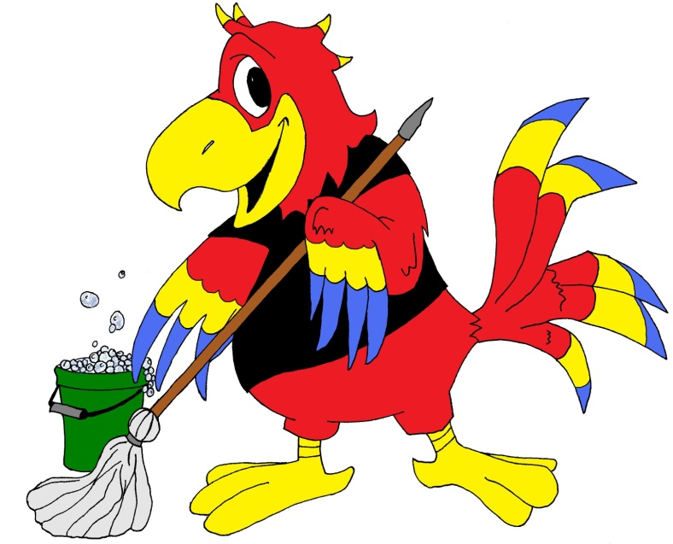
Chris McCaw
Cleaning & Maintenance
Residential & Commercial Cleaning Services
Basic Cleaning Services: Commercial
Entrance & Foyer Areas:
-Trash bins emptied
-Cobweb removal
-General dusting (baseboards and window sills)
-Cleaning of entrance doors and windows
-Vacuuming of floors and rugs
-Mopping of hard floors

Bathrooms:
- Trash bins emptied
-Cobweb removal
-General dusting (including baseboards and window skills)
-Surface cleaning (including vanities, sinks, mirrors, and fixtures)
-Cleaning of showers and tubs
-Cleaning and disinfecting of toilets
-Refilling of hand and toilet paper dispensers (with client-provided product)
-Vacuuming, sweeping, and/or mopping of floors

Work Areas:
-Trash bins emptied
-Cobweb removal
-General dusting (including baseboards and window sills)
-Vacuuming of floors and rugs
-Mopping of hard floors

Kitchen & Break Areas:
-Trash bins emptied
-Cobweb removal
-General dusting (including baseboards and window skills)
-Cleaning of sinks, fixtures, and countertops
-Surface cleaning of appliances
-Surface cleaning of any and all tables
-Vacuuming and sweeping of floors
-Mopping of hard floors

