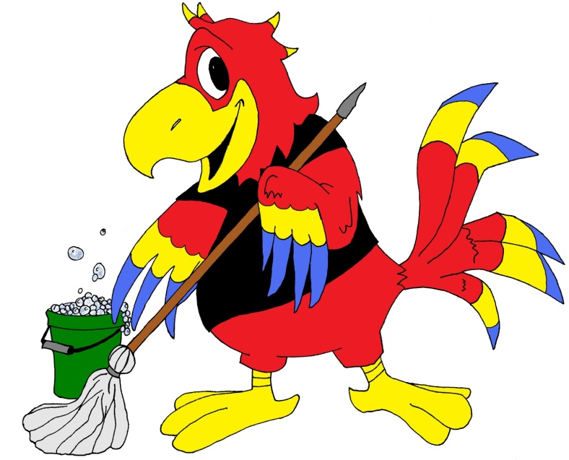
Chris McCaw
Cleaning & Maintenance
Residential & Commercial Cleaning Services
Basic Cleaning Services: Residential
Sleeping & Living Areas:
-Trash bins emptied
-Cobweb removal
-General dusting (including ledges, window sills, light fixtures and ceiling fans)
-Vacuuming of all accessible floors
-Mopping of hard floors

Kitchen & Dining Areas:
-Trash bins emptied
-Cobweb removal
-General dusting (including ledges and window sills)
-Cleaning of sinks, fixtures, and countertops
-Surface cleaning of appliances
-Surface cleaning of any and all tables
-Vacuuming and sweeping of floors
-Mopping of hard floors

Bathrooms:
- Trash bins emptied
-Cobweb removal
-General dusting (including ledges and window skills)
-Surface cleaning (including vanities, sinks, mirrors, and fixtures)
-Cleaning of showers and tubs
-Cleaning and disinfecting of toilets
-Vacuuming, sweeping, and/or mopping of floors

