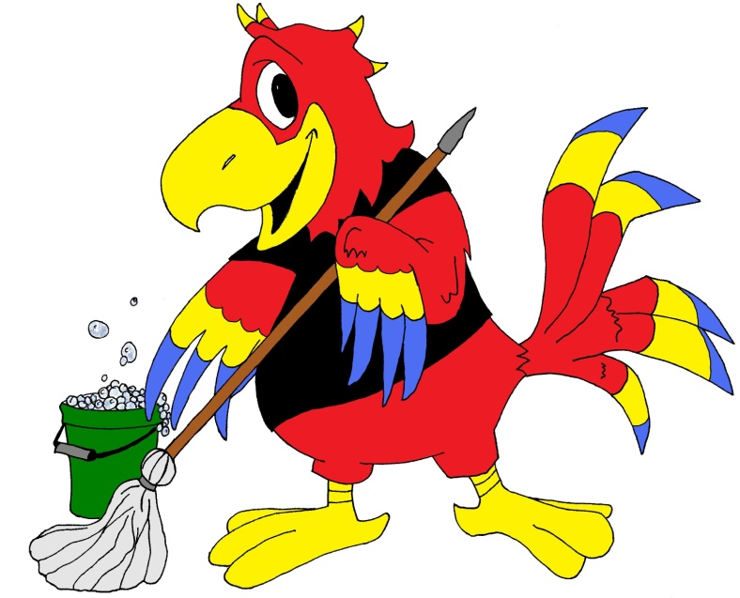
Chris McCaw
Cleaning & Maintenance
Residential & Commercial Cleaning Services
Detailed Cleaning Services: Commercial
Entrance & Foyer Areas:
-Trash bins emptied
-Cobweb removal
-Hand-wiping of entrance doors and windows
-Hand-wiping of any and all light fixtures and ceiling fans
-Hand-wiping of any and all ledges, window skills, and blinds
-Hand-wiping of any and all baseboards, doors, and frames
-Hand-wiping of any and all decorative items or accessories
-Polishing of any and all wood furniture
-Vacuuming of all accessible floors (including carpet edges)
-Mopping of hard floors

Bathrooms:
- Trash bins emptied
-Cobweb removal
--Hand-wiping of any and all light fixtures and ceiling fans
-Hand-wiping of any and all ledges, window skills, and blinds
-Hand-wiping of any and all baseboards, doors, and frames
-Hand-wiping of any and all decorative items or accessories
-Detailed cleaning of vanities, sinks, fixtures, and mirrors
-Scrubbing and disinfecting of toilets
-Refilling of hand and toilet paper dispensers (with client-provided product)
-Vacuuming, sweeping, and/or mopping of floors

Work Areas:
-Trash bins emptied
-Cobweb removal
-Hand-wiping of any and all ledges, window skills, and blinds
-Hand-wiping of any and all baseboards, doors, and frames
-Hand-wiping of any and all decorative items or accessories
-Polishing of any and all wood furniture
-Vacuuming of all accessible floors (including carpet edges)
-Mopping of hard floors

Kitchen & Break Areas:
-Trash bins emptied
-Cobweb removal
-Hand-wiping of any and all light fixtures and ceiling fans
-Hand-wiping of any and all ledges, window skills, and blinds
-Hand-wiping of any and all baseboards, doors, and frames
-Hand-wiping of any and all decorative items or accessories
-Hand-wiping of any and all cabinet surfaces
-Cleaning of sinks, fixtures, and countertops
-Interior and exterior cleaning of appliances
-Surface cleaning of any and all tables
-Vacuuming, sweeping, and/or mopping of floors

Additional Services Available: *
-Steam cleaning of floors, countertops, and appliances
-Oven cleaning
-Shampooing of carpeted areas or rugs
-Vacuuming and deodorizing of upholstery, window treatments, etc.
-Stain removal (including carpets, sofas, etc.)
-Cleaning of interior and exterior windows
-Cleaning of any and all door windows
-Green cleaning (upon request) * Additional fee

